**GUVI: Zen Class — Part 1: Find the culprits and nail them — debugging javascript**

1. Fix the error

<!DOCTYPE html>

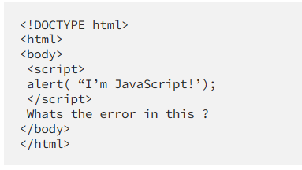<html>

<body>

<script>

**alert("I'm JavaScript!"); // the error part**

</script>

</body>

</html>

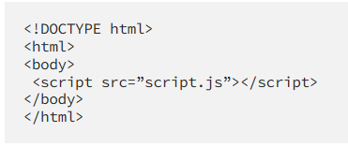2. Fix the Html

<!DOCTYPE html>

<html>

<body>

**<script src="script.js"></script> // the error part**

</body>

</html>

3.

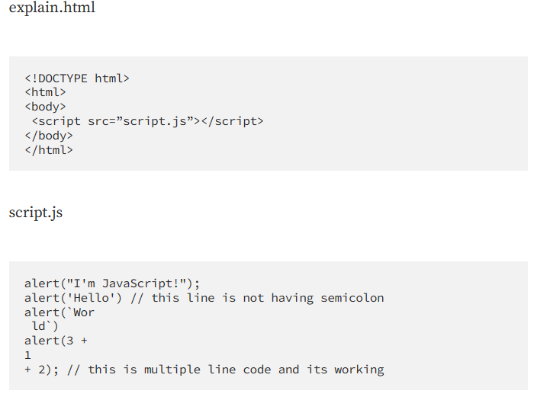

The code in explain.html includes an HTML document that includes a <script> tag with src file that link with an external JavaScript (script.js) file. And this code explain.html and script.js explain basic use of the alert() function and different ways to include strings and expressions as arguments.

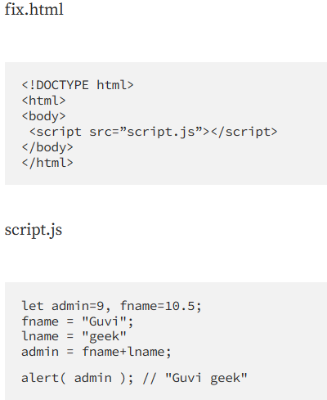4.

<!DOCTYPE html>

<html>

<body>

<script src="script.js"></script>

</body>

</html>

let admin = 9, fname = 10.5;

fname = "Guvi";

let lname = "geek";

**admin = fname + " " + lname; // fixed code**

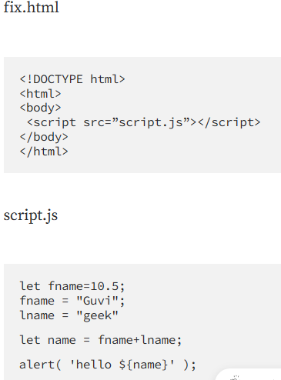 alert(admin); // "Guvi geek"

5.

<!DOCTYPE html>

<html>

<body>

<script src="script.js"></script>

</body>

</html>

let fname = 10.5;

**fname = "Guvi"; //fixed error**

let lname = "geek";

let name = fname + lname;

alert(`hello ${name}`);

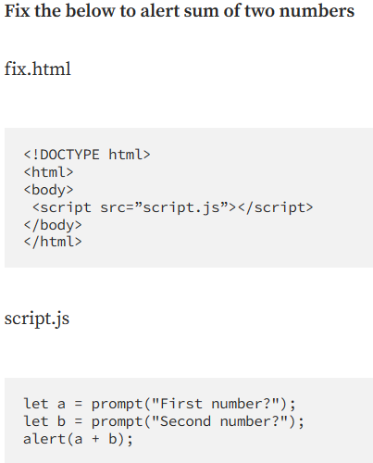6. Fixed JS code

**let a = parseInt(prompt("First number?"));**

**let b = parseInt(prompt("Second number?"));**

alert(a + b);

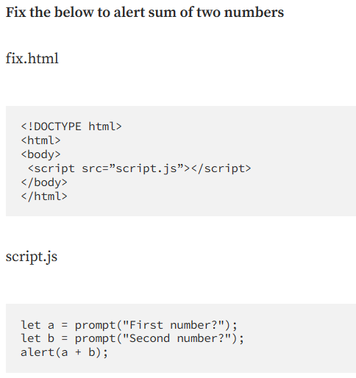7.

**let a = parseInt(prompt("First number?"));**

**let b = parseInt(prompt("Second number?"));**

alert(a + b);

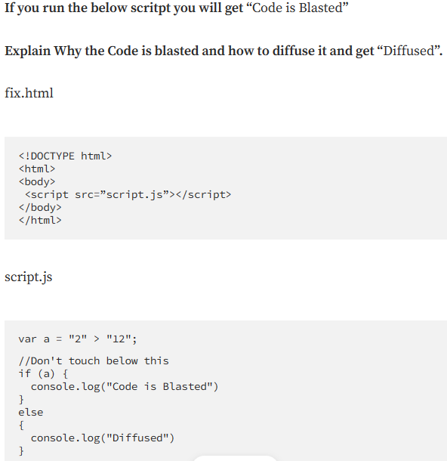8.

**var a = parseInt("2") > parseInt("12");**

if (a) {

console.log("Code is Blasted")

}

else {

console.log("Diffused") }

9.

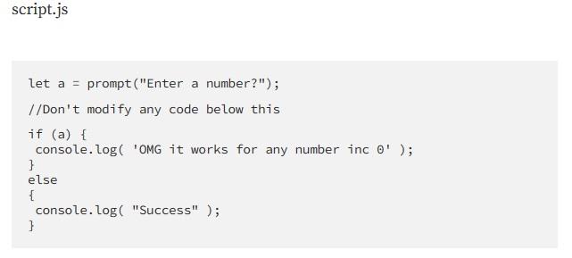 **let a = parseInt(prompt**

**("Enter a number?"));**

10. let value = prompt('How many runs you scored in this ball');

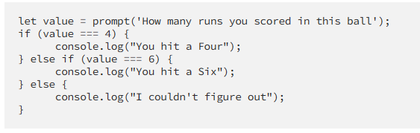**value = parseInt(value);**

if (value === 4) {

console.log("You hit a Four");

} else if (value === 6) {

console.log("You hit a Six");

} else {

console.log("I couldn't figure out"); }

11. **Fix a code to welcome employee:**

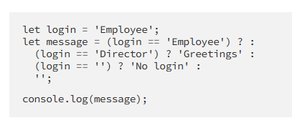let login = 'Employee';

**let message = (login == 'Employee') ? 'Welcome' :**

(login == 'Director') ? 'Greetings' :

(login == '') ? 'No login' :

'';

console.log(message);

12. **Fix the code to welcome the boss**

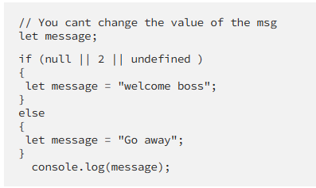let message;

if (null || 2 || undefined ) {

message = "welcome boss";

**message = message.slice(0, 7) + " the" +**

**message.slice(7);**

}

else { message = "Go away";

} console.log(message);

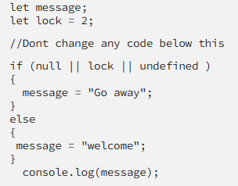

13.

**message += " the boss";**

**console.log(message);**

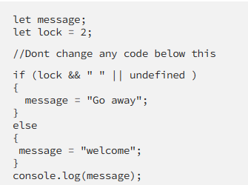14. if (message === "welcome")

{

message = "Welcome the boss";

console.log(message);

}

Else { console.log(message); }

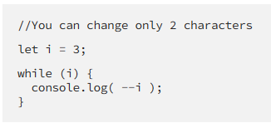15.

let i = 3;

while (i) {

console.log( i-- ); }

16**. Change the code to print 1 to 10 in 4 lines**

let i = 1;

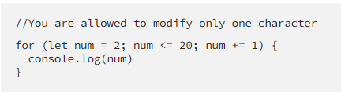while (i<10) {

console.log( i++ ); }

17. **Change the code to print even numbers**

for (let num = 2; num <= 20; num += 2) {

console.log(num)

}

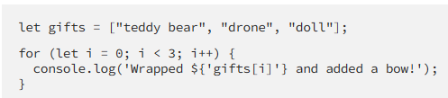18. **Change the code to print all the gifts:**

let gifts = ["teddy bear", "drone", "doll"];

for (let i = 0; i < gifts.length; i++) {

console.log(`Wrapped ${gifts[i]} and added a bow!`);

}

19. **Fix the code to disarm the bomb.**

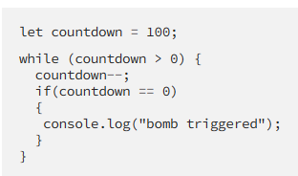let countdown = 100;

while (countdown > 0) {

countdown--;

**if(countdown == 1)**

{

console.log("bomb disarmed");

break;

} }

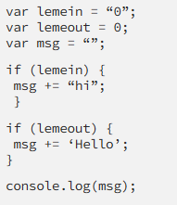20. **Whats the msg printed and why?**

The lemein variable is assigned the string value "0",

which is truthy in JavaScript.

Therefore, the first if statement will evaluate to true,

and the msg variable will be assigned the string "hi".

**GUVI: Zen Class — Part 2 : Find the culprits and nail them — debugging javascript loops**

1. **Write a code to print the numbers in the array**

**Output: 1234567891011**

var numsArr = [1, 2, 3, 4, 5, 6, 7, 8, 9, 10, 11];

var new_string = "";

for (var i = 0; i < numsArr.length; i++) {

new_string += numsArr[i];

}

console.log(new_string);

1. **Write a code to print the numbers in the array**

**Output: 1,2,3,4,5,6,7,8,9,10,11**

var numsArr = [1, 2, 3, 4, 5, 6, 7, 8, 9, 10, 11];

var new_string = "";

for (var i = 0; i < numsArr.length; i++) {

new_string += numsArr[i];

if (i < numsArr.length - 1) {

new_string += ",";

}

}

console.log(new_string);

1. **Write a code to print from last to first with spaces (Make sure there is no space after the last element 1)**

**Output: 11 10 9 8 7 6 5 4 3 2 1**

var numsArr = [[1, 2, 3, 4, 5],[6, 7, 8, 9, 10, 11]];

var str_all = "";

for (var i = 0; i < numsArr.length; i++) {

var inner_array = numsArr[i];

for(var j = 0 ; j < inner_array.length; j++ )

str_all += inner_array[j];

}

console.log(str_all);

1. **Write a code to replace the array value — If the index is even, replace it with ‘even’.**

**Output: [ [“even”, 2, “even”, 4, “even”], [6, “even”, 8, “even”, 10, …] ]**

var numsArr = [[1, 2, 3, 4, 5],[6, 7, 8, 9, 10, 11]];

for (var i = 0; i < numsArr.length; i++) {

var inner_array = numsArr[i];

for(var j = 0 ; j < inner_array.length; j++ ) {

if(inner_array[j] % 2 == 0 ) {

inner_array[j] = 'even'; } } }

console.log(numsArr);

1. **Write a code to print elements in the inner arrays in reverse**

**Output: 11 10 9 8 7 6 5 4 3 2 1**

var numsArr = [[1, 2, 3, 4, 5],[6, 7, 8, 9, 10, 11]];

var str_all = "";

for (var i = numsArr.length - 1; i >= 0; i--) {

var inner_array = numsArr[i];

for (var j = inner_array.length - 1; j >= 0; j--) {

str_all += inner_array[j] + " ";

} }

console.log(str_all.trim());

1. **Write a code to add elements in the inner arrays based on odd or even values**

**Output:**

**36**

**30**

var numsArr = [[1, 2, 3, 4, 5],[ 6, 7, 8, 9, 10, 11]];

var sum_odd=0;

var sum_even=0;

for (var i = 0; i < numsArr.length; i++) {

var inner_array = numsArr[i];

for(var j = 0 ; j < inner_array.length;j++ ){

if(inner_array[j]%2!=0) {

sum_odd += inner_array[j];

} else {

sum_even += inner_array[j];

}

}

}

console.log(sum_odd);

console.log(sum_even);

**GUVI: Zen Class — Part 3: Find the culprits and nail them — debugging javascript**

1. **Fix the code to get the largest of three.**

aa = (f, s, t) => {

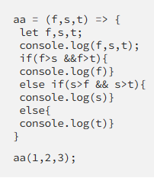 console.log(f, s, t);

if(f > s && f > t) {

console.log(f);

} else if(s > f && s > t) {

console.log(s);

} else {

console.log(t);

}

}

aa(1, 2, 3);

1. **Fix the code to Sum of the digits present in the number**

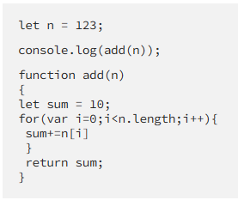

let n = 123;

console.log(add(n));

function add(n) {

let sum = 0;

n = n.toString();

for(var i = 0; i < n.length; i++) {

sum += parseInt(n[i]);

}

return sum;

}

1. **Fix the code to Sum of all numbers u** **sing IIFE function**

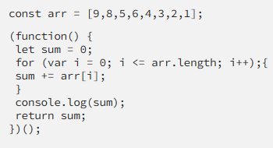const arr = [9,8,5,6,4,3,2,1];

(function() {

let sum = 0;

for (var i = 0; i < arr.length; i++) {

sum += arr[i];

}

console.log(sum);

return sum;

})();

1. 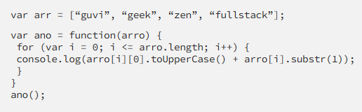**Fix the code to gen Title caps.**

var arr = ["guvi", "geek", "zen", "fullstack"];

var ano = function(arro) {

for (var i = 0; i < arro.length; i++) {

console.log(arro[i][0].toUpperCase()

+ arro[i].substr(1));

}

};

ano(arr);

1. **Fix the code to return the Prime numbers**

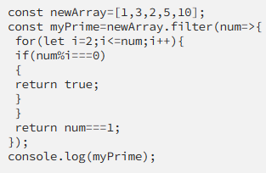const newArray = [1, 3, 2, 5, 10];

const myPrime = newArray.filter(num => {

for (let i = 2; i < num; i++) {

if (num % i === 0) {

return false;

} } return num !== 1;

});

console.log(myPrime);

1. **Fix the code to sum the number in that array**

const num = [10, 20, 30, 40, 50, 60, 70, 80, 90, 100];

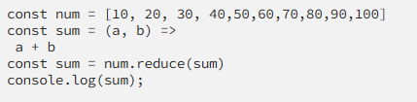const add = (a, b) => a + b;

const result = num.reduce(add);

console.log(result);

1. **Fix the code to rotate an array by k times and return rotated array using IIFE function.**

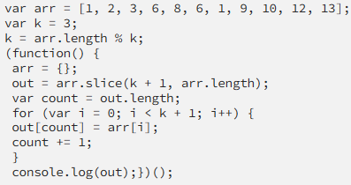 var arr = [1, 2, 3, 6, 8, 6, 1, 9, 10, 12, 13];

var k = 3;

k = k % arr.length;

// Calculate the actual rotation value

(function() {

var out = arr.slice(k, arr.length).concat(arr.slice(0, k));

// Rotate the array using slice() and concat()

console.log(out);

})();

1. **Fix the code to gen Title caps.**

var arr = ["guvi", "geek", "zen", "fullstack"];

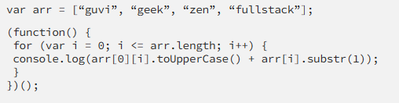

(function() {

for (var i = 0; i < arr.length; i++) {

console.log(arr[i][0].toUpperCase()

+ arr[i].substr(1));

}

})();

1. **print all odd numbers in an array using IIFE function**

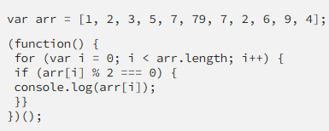

var arr = [1, 2, 3, 5, 7, 79, 7, 2, 6, 9, 4];

(function() {

for (var i = 0; i < arr.length; i++) {

if (arr[i] % 2 !== 0) {

console.log(arr[i]);

}}

})();

1. 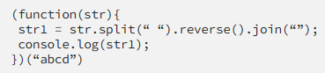**Fix the code to reverse.**

(function(str){

var str1 = str.split("").reverse().join("");

console.log(str1);

})("abcd");

1. **Fix the code to remove duplicates.**

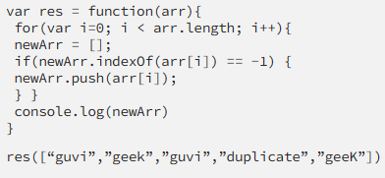var res = function(arr){

var newArr = [];

for(var i=0; i < arr.length; i++){

if(newArr.indexOf(arr[i].toLowerCase()) == -1) {

newArr.push(arr[i].toLowerCase());

}

}

console.log(newArr);

}

res(["guvi","geek","guvi","duplicate","geeK"]);

1. **Fix the code to give the below output:**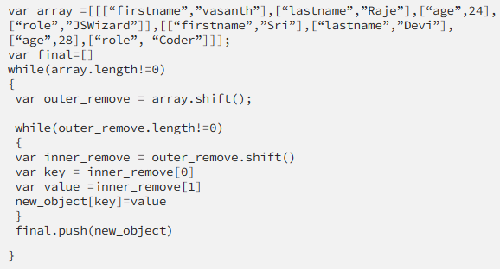

var array = [ [ ["firstname", "vasanth"],

["lastname", "Raja"],

["age", 24],

["role", "JSWizard"]

],

[ ["firstname", "Sri"],

["lastname", "Devi"],

["age", 28],

["role", "Coder"]

]

];

var final = [];

while (array.length != 0) {

var outer_remove = array.shift();

var new_object = {};

while (outer_remove.length != 0) {

var inner_remove = outer_remove.shift();

var key = inner_remove[0];

var value = inner_remove[1];

new_object[key] = value;

}

final.push(new_object);

}

console.log(final);

1. 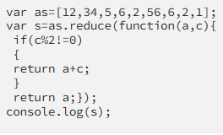**Fix the code to give the below output:**

**Sum of odd numbers in an array**

var as = [12, 34, 5, 6, 2, 56, 6, 2, 1];

var s = as.reduce(function(a, c) {

if (c % 2 != 0) {

return a + c;

}

return a;

});

console.log("The sum of odd numbers in the array is: " + s);

1. **Swap the odd and even digits**

const aa = data => {

let l = '';

for (let i = 0; i < data.length; i += 2) {

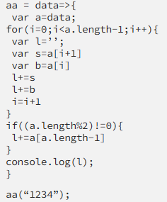 if (i < data.length - 1) {

l += data[i + 1];

}

l += data[i];

}

console.log(l);

};

aa("1234"); // Output: "2143"